Python Programming Course in Hindi (Advanced)

Chapter 12 – Advanced Python 1

**Exception Handling in Python**

There are many built-in exceptions that are raised in Python when something goes wrong.

Exceptions in Python can be handled using a try statement. The code that handles the exception is written in except clause.

'''

try:

#code #Code that might throw an exception

except Exception as e:

print(e)

'''

Copy

When the exception is handled, the code flow continues without program interruption.

We can also specify the exceptions to catch like below:

'''

try:

#code

except ZeroDivisionError:

#code

except TypeError:

#code

except:

#code (All other exceptions are handled here)

'''

Copy

**Raising Exceptions**

We can raise custom exceptions using the raise keyword in python.

**try with else clause**

Sometimes we want to run a piece of code when try was successful.

'''

try:

#some code

except:

#some code

else:

#Code (This is executed only if the try was successful)

'''

Copy

**try with finally**

Python offers a finally clause which ensures execution of a piece of code irrespective of the exception.

'''

try:

#some code

except:

#some code

finally:

#some code (executed regardless of error!)

'''

Copy

**if __name__==’__main__’ in Python**

__name__ evaluates to the name of the module in Python from where the program is ran.

If the module is being run directly from the command line, the __name__ is set to string “__main__”.

Thus this behavior is used to check whether the module is run directly or imported to another file.

**The global keyword**

global keyword is used to modify the variable outside of the current scope.

**enumerate function in Python**

The enumerate function adds counter to an iterable and returns it.

for i, item in list1:

print(i, item) #Prints the items of list1 with index!

Copy

**List comprehensions**

List comprehensions is an elegant way to create lists based on existing lists.

list1 = [1, 7, 12, 11, 22]

list2 = [i for item in list1 if item>8]

Chapter 12 – Practice Set

1. Write a program to open three files 1.txt, 2.txt, and 3.txt. if any of these files are not present, a message without exiting the program must be printed prompting the same.
2. Write a program to print the third, fifth, and seventh elements from a list using the enumerate function.
3. Write a list comprehension to print a list that contains the multiplication table of a user-entered number.
4. Write a program to display a/b where a and b are integers. If b=0, display infinite by handling the ZeroDivisionError.
5. Store the multiplication tables generated in problem 3 in a file named Tables.txt.

Chapter 13 – Advanced Python 2

**Virtual Environment**

An environment that is same as the system interpreter but is isolated from the other python environments on the system.

**Installation**

To use virtual environments, we write

pip install virtualenv          #Installs the package

We create a new environment using:

virtualenv myprojectenv             #Creates a new venv

The next step after creating the virtual environment is to activate it.

We can now use this virtual environment as a separate python installation.

**pip freeze command**

pip freeze returns all the packages installed in a given python environment along with the versions.

“pip freeze > requirements.txt”

The above command creates a file named requirements.txt in the same directory containing the output of pip freeze.

We can distribute this file to other users and they can recreate the same environment using:

pip install –r requirements.txt

**Lambda functions**

Functions created using an expression using the lambda keyword

Syntax:

lambda arguments: expressions (can be used as a normal function)

Example:

Square = lambda x: x*x

Square(6) #returns 36

Sum = lambda a,b,c: a+b+c

Sum(1,2,3) #returns 6

Copy

**bin method(Strings)**

Creates a string from iterable objects

l = [“apple”, “mango”, “banana”]

“,and,”.join(l)

Copy

The above line will return “apple, and, mango, and, banana”

**Format method(Strings)**

Formats the values inside the string into the desired output

template.format(p1, p2, …)        #p1, p2 … are the arguments

The syntax for format looks like:

“{} is a good {}”.format(“Harry”,”boy”) – 1

“{1} is a good {0}”.format(“Harry”, “boy”) – 2

Copy

Output for 1:

Harry is a good boy

Output for 2:

boy is a good Harry

**Map, Filter & Reduce**

Map applies a function to all the items in an input_list.

**Syntax:**

map(function, input_list)             #function can be lambda function

Filter creates a list of items for which the function returns true.

list(filter(function))            #function can be a lambda function

Reduce applies a rolling computation to sequential pair of elements.

from functools import reduce

val = reduce(function, list1)        #function can be a lambda function

If the function computes sum of two numbers and the list is [1, 2, 3, 4]

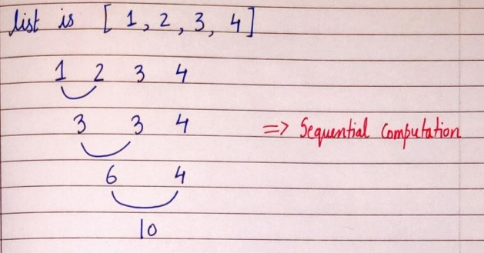

Chapter 13 – Practice Set

1. Create two virtual environments, install few packages in the first one. How do you create a similar environment in the second one?
2. Write a program to input name, marks and phone number of a student and format it using the format function like below:

“The name of the student is Harry, his marks are 72 and the phone number is 99999888”

1. A list contains the multiplication table of 7. Write a program to convert it to a vertical string of the same numbers (7,14,….)
2. Write a program to filter a list of numbers that are divisible by 5.
3. Write a program to find the maximum of the numbers in a list using the reduce function.
4. Run pip freeze for the system interpreter. Take the contents and create a similar virtualenv.
5. Explore the flask module and create a web server using flask and Python.

Project 3: Student Library

Implement a student library system using OOPs where students can borrow a book from the list of books.

Create a separate Library and Student class.

Your program must be menu-driven.

You are free to choose the methods and attributes of your choice to implement this functionality.